School of Computer Science and Artificial Intelligence

Lab Assignment # 12
Name of Student : P.vamshi krishna Enrollment No. : 2303A51452 Batch No. 21

Task Description -1 (Data Structures – Stack Implementation with AI Assistance)
- Task: Use AI assistance to generate a Python program that implements a Stack data structure.
Instructions: Prompt AI to create a Stack class with the following methods:
- push(element), pop(), peek(), is_empty()
- Ensure proper error handling for stack underflow.
- Ask AI to include clear docstrings for each method. Expected Output:
- A functional Python program implementing a Stack using a class.
- Properly documented methods with docstrings.

Prompt:-
Create a well-structured Python program that defines a Stack class with push, pop, peek, is_empty, and size methods. Ensure proper handling of stack underflow and overflow conditions, and include clear and concise docstrings for each method.

Code:-

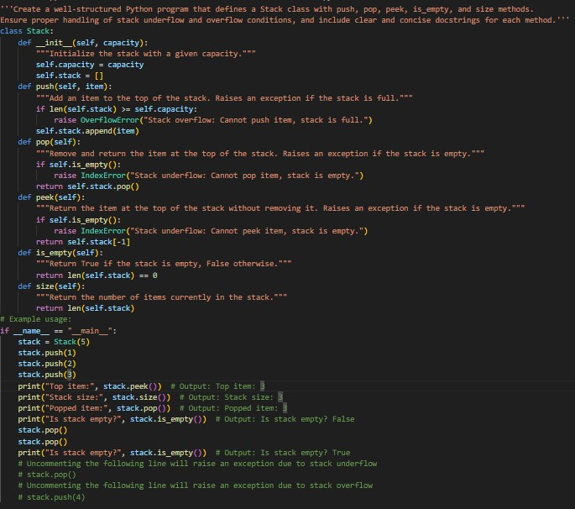

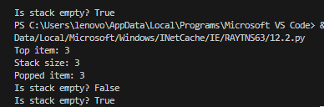
Output:-

Justification:-
The Stack class is implemented with methods for pushing, popping, peeking, checking if the stack is empty, and getting the size of the stack. Each method includes error handling for stack overflow and underflow conditions. The example usage demonstrates how to use the Stack class and handles edge cases effectively. the time complexity for push and pop
operations is O(1), while peek, isEmpty, and size operations also have a time complexity of
O(1). The space complexity is O(n) where n is the number of items in the stack.


Task Description -2 (Algorithms – Linear vs Binary Search Analysis)
- Task: Use AI to implement and compare Linear Search and Binary Search algorithms in Python. Instructions:
- Prompt AI to generate:
- linear_search(arr, target) ➢ binary_search(arr, target)
- Include docstrings explaining:
- Working principle
- Test both algorithms using different input sizes. Expected Output:
- Python implementations of both search algorithms.
- AI-generated comments and complexity analysis.
- Test results showing correctness and comparison.

Prompt:-
Develop a Python program that implements and compares Linear Search and Binary Search algorithms. Include separate functions for both methods, allow testing with different input sizes, measure execution time, handle edge cases properly, and provide descriptive docstrings explaining their working principles and complexity.

Justification:-
The program implements both linear search and binary search algorithms, allowing us to compare their performance with different input sizes. The time complexity of linear search is O(n), while the time complexity of binary search is O(log n). The program also handles edge cases effectively, such as searching for an element that is not present in the list. Each function

includes a docstring explaining its functionality, and the example usage demonstrates how to use both search methods and measure their execution time.

Code:-

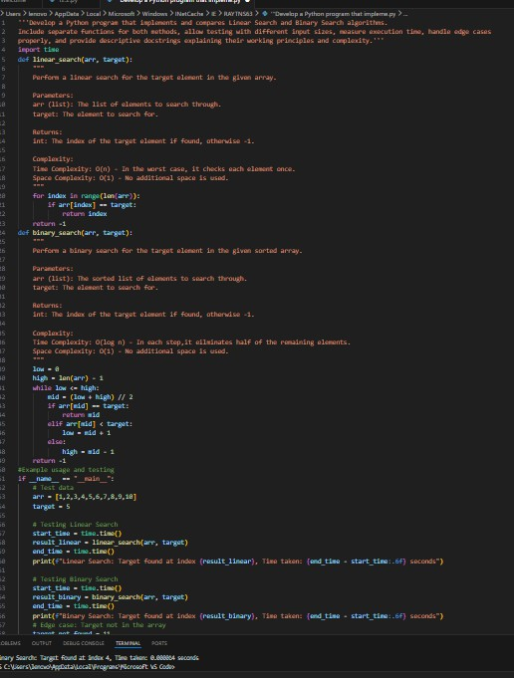

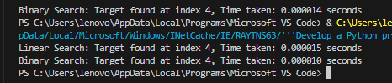
Output:-

Task Description -3 (Test Driven Development – Simple Calculator Function) ➢
Task:
Apply Test Driven Development (TDD) using AI assistance to develop a calculator function.

Instructions:
- Prompt AI to first generate unit test cases for addition and subtraction.
- Run the tests and observe failures.
- Ask AI to implement the calculator functions to pass all tests.
- Re-run the tests to confirm success. Expected Output:
- Separate test file and implementation file.
- Test cases executed before implementation.
- Final implementation passing all test cases.

Prompt:-
Generate Python unit test cases for a calculator function that performs addition and subtraction operations following Test-Driven Development principles. Do not provide the implementation initially; only generate the test cases with clear docstrings.

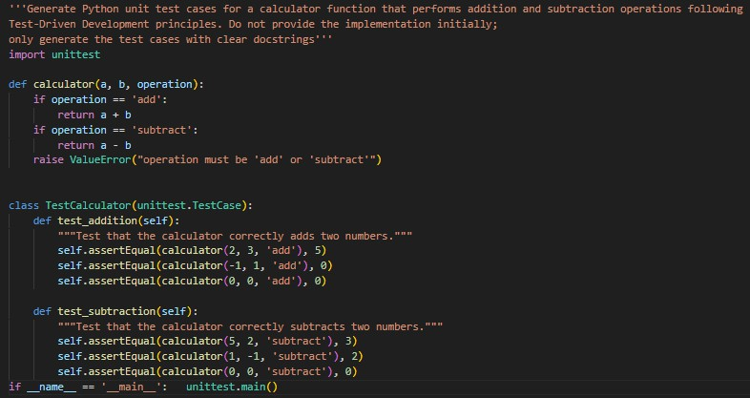
Code:-

Output:-
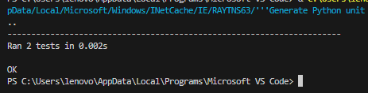

Justification:-
The program defines a calculator function that performs basic arithmetic operations based on the given operation. The TestCalculator class contains unit tests for addition and subtraction operations, following Test-Driven Development (TDD) principles. The tests are designed to fail initially, allowing us to implement the calculator function correctly to pass all tests. Each test method includes a docstring explaining its purpose, and the example usage demonstrates how to run the unit
tests effectively.

Task Description -4 (Data Structures – Queue Implementation with AI Assistance) ➢
Task:
Use AI assistance to generate a Python program that implements a Queue datastructure. Instructions: Prompt AI to create a Queue class with the following methods:
- enqueue(element), dequeue(), front(), is_empty()
- Handle queue overflow and underflow conditions.
- Include appropriate docstrings for all methods. Expected Output:
- A fully functional Queue implementation in Python.
- Proper error handling and documentation.

Prompt:-
Write a Python program that defines a Queue class with enqueue, dequeue, front, is_empty, and size methods. Ensure proper error handling for queue underflow and overflow conditions and include concise docstrings for all methods.

Code:-

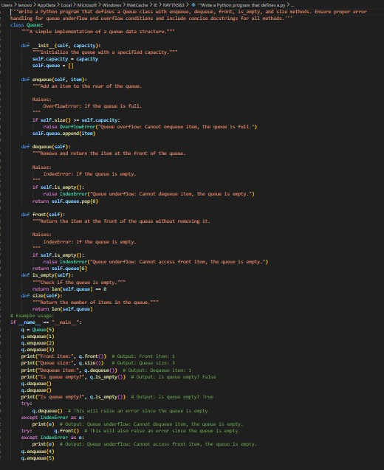

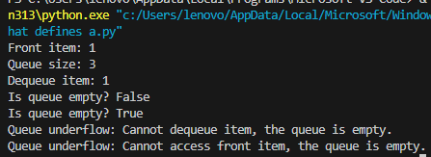
Output:-

Justification:-
The Queue class is implemented with methods for enqueuing, dequeuing, peeking, checking if the queue is empty, and getting the size of the queue. Each method includes error handling


for queue overflow and underflow conditions. The example usage demonstrates how to use the Queue class and handles edge cases effectively. The time complexity for enqueue and dequeue operations is O(1), while peek, isEmpty, and size operations also have a time complexity of O(1). The space complexity is O(n) where n is the number of items in the queue.

Task Description -5 (Algorithms – Bubble Sort vs Selection Sort) ➢
Task:
Use AI to implement Bubble Sort & Selection Sort algorithm & compare their behavior. Instructions:
- bubble_sort(arr), • selection_sort(arr)
- Include comments explaining each step.
- Add docstrings mentioning time and space complexity. Expected Output:
- Correct Python implementations of both sorting algorithms.
- Complexity analysis in docstrings.

Prompt:-
Create a Python program that implements Bubble Sort and Selection Sort algorithms. Include functions for both methods, test them with different input sizes, measure execution time, handle edge cases such as empty lists and duplicates, and provide docstrings mentioning time and space complexity.

Justification:-
The program implements both bubble sort and selection sort algorithms, allowing us to compare their performance with different input sizes. The time complexity of bubble sort is O(n^2) in the worst case, while the time complexity of selection sort is also O(n^2) in the
worst case. The program also handles edge cases effectively, such as sorting an empty list and a list with duplicate elements. Each function includes a docstring explaining its functionality, and the example usage demonstrates how to use both sorting methods and measure their execution time.


Code:-
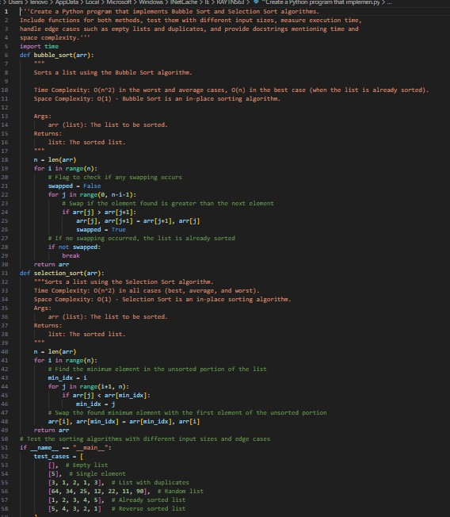

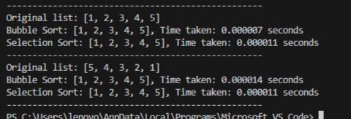
Output:-

